YEAR 12 Essentials Mathematics
Semester 1 2017
Test 5 – Probability

.

Total Marks: 31 marks
Name: ______________________ Total Time: 50 minutes


Full working out must be shown to get full marks.

Attempt all questions

Total Time: 50 minutes

Resources allowed:

1 A4 page, (1 side) of hand written notes, ruler

Calculator

- As of 2014, the distribution of blood types in Australia is as follows:
Blood group | RhD | % of population
O | O+ | 40
 | O- | 9
A | A+ | 31
 | A- | 7
B | B+ | 8
 | B- | 2
AB | AB+ | 2
 | AB- | 1

- What is the probability that an Australian resident will have B+ blood type? (1 mark)

- Every week, Australia needs over 27,000 blood donations. How many of these blood donations could be from people with A+ blood type? (3 marks)

- The following tree diagram represents the possible outcomes of a family which has two children.

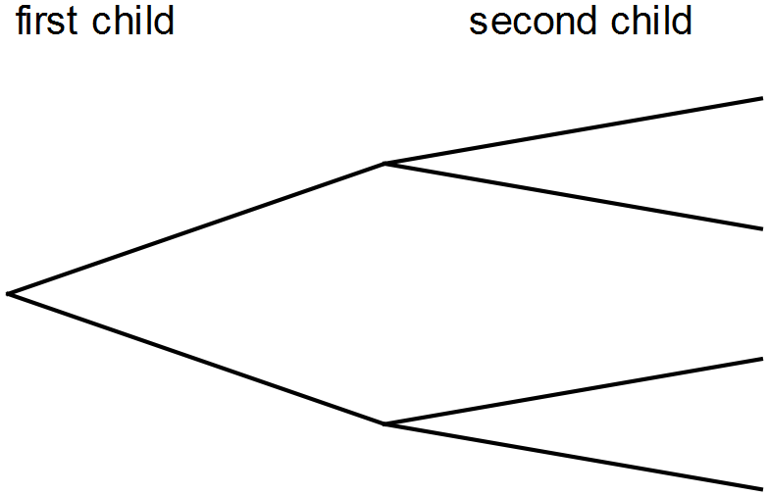

- Label the diagram to show the possibilities of boy and girl. (2 marks)

- What is the chance the family would have two girls? (2 marks)

- If the family had a third child, what is the chance there would be two girls and a boy?
(4 marks)

3. An agricultural research company has completed an investigation into the effect of a new fertiliser on plant growth. The heights of 50 plant seedlings grown under experimental conditions for several weeks were measured and recorded to the nearest centimetre. The heights are listed here.

107, 162, 151, 145, 133, 125, 116, 108, 111, 113, 125, 126, 158, 142, 139,
165, 168, 152, 141, 147, 147, 131, 137, 137, 111, 119, 121, 125, 125, 156,
117, 133, 138, 157, 124, 124, 159, 132, 131, 139, 141, 137, 129, 131, 148,
127, 136, 136, 121, 148
- Use the data above to complete the table below: (3 marks)

Height (cm) | Frequency | Relative Frequency
 | 2 | 0.04
 | 6 | 0.12
 | 11 | 0.22
 | 14
 | 8

- What is the probability of plants growing to a height between 120 cm and 129 cm?
(2 marks)

- What is the probability of plants growing to a height of at least 140 cm? (2 marks)

- If the experiment is expanded to 1000 plants, how many plants would you expect to grow to a height of at least 130 cm? (2 marks)

- The fertiliser is considered effective if 75% of seedlings have a height of 130 cm or more. Comment on the effectiveness of the fertiliser on plant growth, based on the results from the experiment. (3 marks)

4. To win a prize in the Wheat Flakes company’s Cereal Prize Giveaway, customers must collect all of the letters of the word CEREAL from packets of Wheat Flakes.
One letter is placed in each packet of Wheat Flakes. This process is repeated over and over.

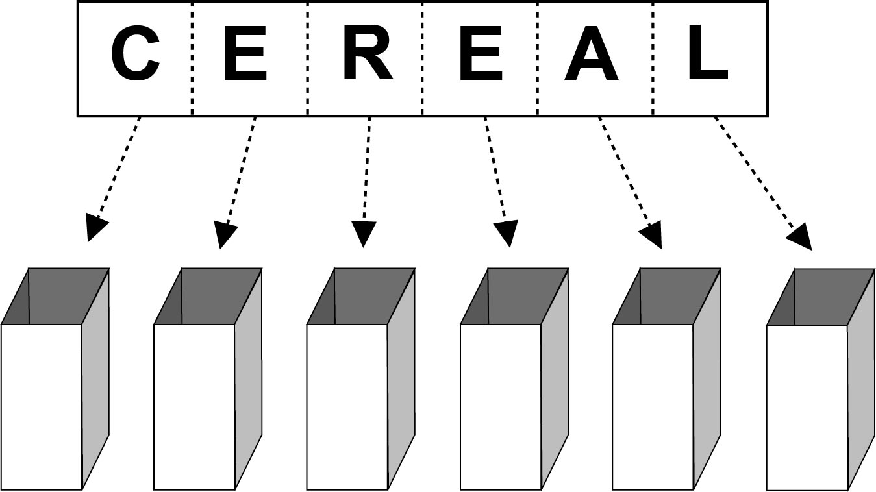

Nguyen wants to be able to estimate the number of packets of Wheat Flakes he would need to purchase, on average, before he is likely to win a prize.
Nguyen uses random numbers from his calculator to simulate the selection of letters for this situation. He assigns letters to random numbers, as in the table below:

Number range | Letter
000 – 099 | A
100 – 199 | C
200 – 399 | E
400 – 499 | L
500 – 599 | R

Any number greater than or equal to 600 is ignored.
- Why are 200 numbers assigned to the letter E and only 100 numbers to the other letters?
(1 mark)

The first 20 random numbers that Nguyen gets from his calculator are shown below, with his first number being 242, the second, 413, and so on.

242 | 413 | 176 | 075 | 500 | 832 | 416 | 974 | 587 | 004
723 | 124 | 543 | 219 | 853 | 361 | 643 | 054 | 387 | 634

(b) Use Nguyen’s random numbers to assign letters until you have spelt the word CEREAL.
(3 marks)

Random number used | Letter
242 | E
413
176

(c) How many packets of Wheat Flakes would Nguyen need to buy to win a prize in this competition, on the basis of the results in part (b)? (1 mark)

(d) If you ran this simulation with your calculator, what would be the minimum number of times you would need to generate a random number to spell CEREAL? (1 mark)

(e) Nguyen’s friend Georgina buys 30 packets of Wheat Flakes. Will she definitely win a prize? Explain. (1 mark)

